CASE 4
Carlsberg in Emerging Markets

A breeze of optimism blew through the office of Carlsberg A/S’s CEO, Jørgen Buhl Rasmussen. After finally gaining 100 percent control over the giant Russian brewery Baltic Beverages Holding (BBH), and with the investments in Western China beginning to bear fruit, the newly appointed CEO was confident that the Danish brewing company’s intensified focus on emerging markets would pay off. The company was counting on tap- ping the massive potential in emerging markets in order to achieve a much-needed reduction in its dependency on the maturing and stagnating Western European beer markets, which accounted for a full 61 percent of the company’s revenue in 2007.

Indeed, Carlsberg’s emerging market efforts had come a long way. In the Russian market, which was considered to be one of the fastest-growing beer markets in the world, Carlsberg enjoyed market-leader status through its ownership of BBH. In that market, it had a sales volume of approximately 23 million hectoliters of beer in 2007 and revenue of kr 9 billion (US$1.8 billion). As for the highly promising Chinese market, which was regarded as the world’s largest beer market in terms of population and size, the Danish company had achieved a 55 percent market share in the western parts of the country, and it operated 20 brewery plants in China with close to 5,000 employees. In fact, as Carlsberg recognized that the European markets would eventually reach a point of saturation, the aim of the Chinese investments was to create a platform for future growth and revenue.

The outlook for Carlsberg had not always been as bright as it appeared by 2008. Carlsberg’s emerging market strategy had taken a long and winding road. For instance, Carlsberg’s acquisition of the BBH shares was the result of a troubled and expensive partnership with Norwegian Orkla ASA. In addition, before Carlsberg had become successful in the western provinces of China, the company had spent plenty of valuable time and resources trying to enter the rich provinces of southeast- ern China, a strategy that had failed. Furthermore, in the early 2000s, Carlsberg was on the brink of being reduced to a secondary player in the global beer market—as the consolidation of the industry proceeded, Carlsberg A/S
became an obvious takeover target and was also at risk of being cornered as a small regional player. Nonetheless, in 2008 as the first decade of the millennium neared an end, Carlsberg was the fifth-largest brewery in the world in terms of volume produced. Much of this reversal of fortune could be attributed to the company’s emerging market focus.

Despite Buhl Rasmussen’s optimism about the future, the real question was how Carlsberg A/S could success- fully continue to capitalize on its growing engagement in emerging markets. “We don’t know how large the Chinese market will be in five years, and I don’t know if China can become a new BBH,” the CEO explained,
“but it is definitely not impossible, as the market is enormous.” It was no surprise that competition was becoming increasingly fierce in this booming emerging market, and history had clearly proven that doing busi- ness successfully in this market required unconventional approaches.

Introducing Carlsberg A/S

The successful course and strategy which Carlsberg has pursued in recent years will remain basically the same no matter what. The strategy has proved its worth with growth and better results, and it is now strongly rooted in our organization. Our business is thus to focus on the beer markets in Western Europe, Eastern Europe and Asia.
— Carlsberg A/S CEO, Jørgen Buhl Rasmussen

As the fifth-largest brewing company in the world, Carlsberg A/S’s vision was “our brands will be the consumer’s first choice, and we will lead our industry in profitability and growth through a culture of quality, innovation and continuous improvement.” Moreover, Carlsberg saw itself as “probably the best beer company in the world.”

The core businesses of Carlsberg A/S were brewing, marketing and selling beer. In 1847, J.C. Jacobsen opened the doors of Carlsberg A/S’s first brewery in Copenhagen, Denmark, and the first foreign brewery was established in Malawi in 1968. In 2007, the company had 33,000
employees, held a portfolio of 75 breweries around the world and sold approximately 115 million hectoliters of beer in more than 150 countries, with net revenue of kr44,750 million (€6,000 million) (see Exhibit 1). 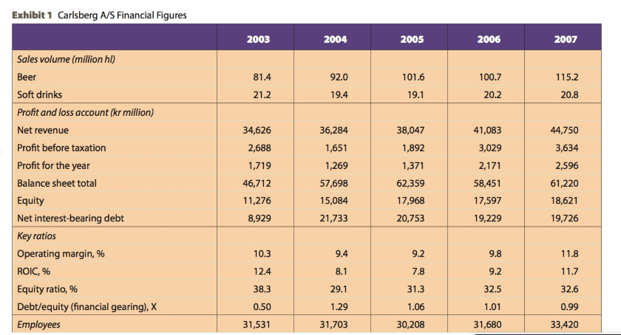Carlsberg’s areas of operation focused on the mature beer markets of Western Europe, the growth markets of Eastern Europe and the emerging Asian markets. Behind this strong position of the company was a major reorientation and restructuring of the company in recent years:
“Progress in revenue and share prices has been driven by a fundamental revolution of the company,” explained former CEO Nils Smedegaard Andersen. “We have purchased and then professionalized the business. At the same time, we have worked with the structure.”

Organization

Despite Carlsberg’s position as the fifth-largest brewery in the world by 2008 (see Exhibits 2 and 3), at the beginning of the 2000s, it had found itself largely excluded from the league of large international breweries. Carlsberg, it then seemed, was losing ground as one of the strongest brands in the world, and was considered by analysts to be an obvious takeover target for larger breweries. In an attempt to cope with these difficulties, a merger with Norwegian Orkla ASA’s brewing activities was executed in 2000 and resulted in the creation of Carlsberg Breweries. Carlsberg A/S owned 60 percent 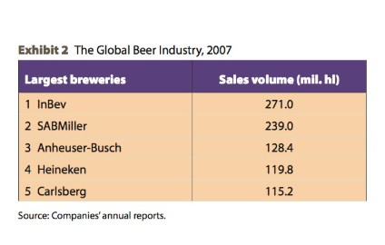
of the new entity, while Orkla held 40 percent. Among the positive aspects of this merger was Orkla ASA’s 50 percent ownership in Baltic Beverages Holdings (BBH), which offered Carlsberg the possibility to strengthen its position in the Eastern European markets. However, after a number of strategic disagreements, Carlsberg bought Orkla out of the merger in 2004. Although this move put Carlsberg into severe debt, former CEO Nils Smedegaard Andersen was content: “We are market leaders in a hand- ful of large countries, we own half of the largest brewery in Eastern Europe and we possess a majority share in a number of European breweries.” He also emphasized that “the acquisition of Orkla’s Carlsberg shares, as well as Holsten, prove that, during the last five years, we have reached a size and economic capacity that allow us to invest very large sums of money.”

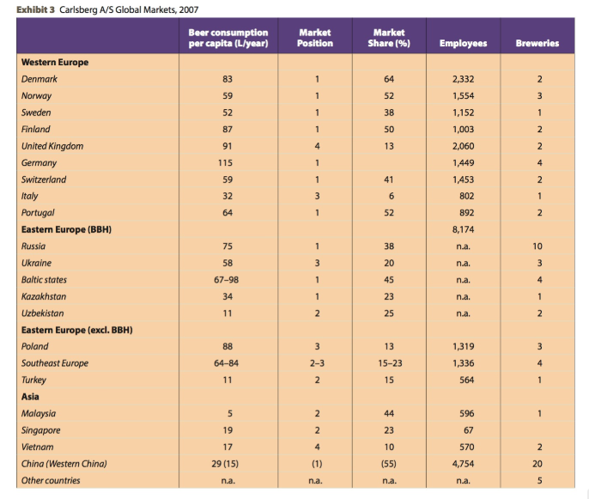
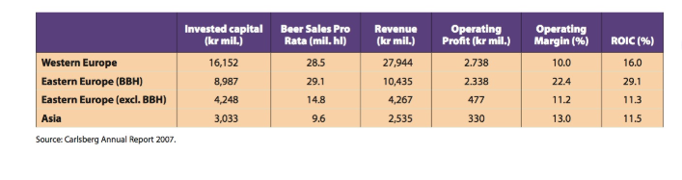
In retrospect, Carlsberg’s ownership structure was a main contributor to the difficulties of financing expansion. The largest shareholder of Carlsberg A/S was the Carlsberg Foundation, which was established by J.C. Jacobsen in 1876 with the purpose of funding scientific research and social work. The Foundation was obliged to own at least 51 percent of Carlsberg A/S’s shares, which hindered the quick release of capital for acquisitions and blocked potential fusions with large, foreign breweries. This was a serious disadvantage for an international brewery fighting to be among the top players in a rapidly consolidating industry.

Carlsberg A/S appeared unable to secure continuous growth and development, and many feared that the company would become a superfluous player. However, after the buyout of Orkla ASA, Carlsberg’s management started to look forward. As Povl Krogsgaard-Larsen, the Carlsberg Foundation’s chairman, pointed out, “We then began to prepare ourselves for our next move, namely to change the charter of the Foundation. This would give Carlsberg more freedom to act, as the Foundation was locked in terms of capital after we bought Orkla’s shares back.” As a result of this process, the Foundation was obligated to own only 25 percent of Carlsberg A/S shares after May 2007, which created more room for new capital.

In May 2008, Carlsberg, in cooperation with Heineken, completed a kr104 billion (US$22 billion) acquisition of the largest British brewer, Scottish & Newcastle. This acquisition gave Heineken control over Scottish & Newcastle’s British activities, while Carlsberg obtained the remaining 50 percent of the Russian brewery Baltic Beverages Holding. Naturally, this major acquisition increased Carlsberg’s debt, which reached kr58.3 billion in May 2008 (US$12.1 billion).

Towards an Emerging Market Strategy

With global beer brands such as Carlsberg Pilsner (“Probably the best beer in the world”), regional brands such as Tuborg, Holsten and Baltika, and a number of leading local brands, Carlsberg’s most important markets were in Western Europe, which accounted for 61 percent of revenue in 2007. Furthermore, the company held a strong position in the growth markets of Eastern Europe and in the emerging Asian markets, with Russia and China serving as the most notable examples. The booming Indian market was also regarded as a market of increasing importance. The Eastern European and Asian markets accounted for 33 percent and 6 percent of revenue in 2007, respectively (see Exhibit 3).

The global brewing industry of the mid-2000s was characterized by a process of intense consolidation, in which the number of breweries continuously declined. By 2007, the industry was basically controlled by the four largest breweries in the world (see Exhibit 4). This consolidation process could be ascribed to changes in consumers’ beer-drinking habits as well as increasing production costs. In the mature European and American markets, beer consumption had been falling as a result of growing health consciousness and increased competition from wine and spirits, while the Eastern European and Asian beer markets were booming. Given the rising costs of inputs, such as glass, aluminum and hops, the large breweries were seeking to consolidate and increase their market share as they searched for economies of scale in relation to everything from production to advertising. For the consolidation of foreign markets, acquisitions and joint ventures with local firms were the preferred modes of entry for the largest companies in the beer industry, as they allowed acquiring companies to gain access to local brands, distributional networks and local market knowledge through partnerships with local breweries.

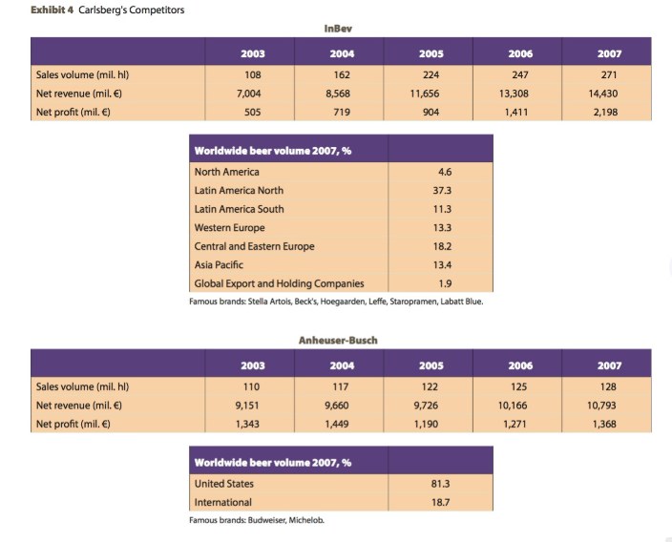
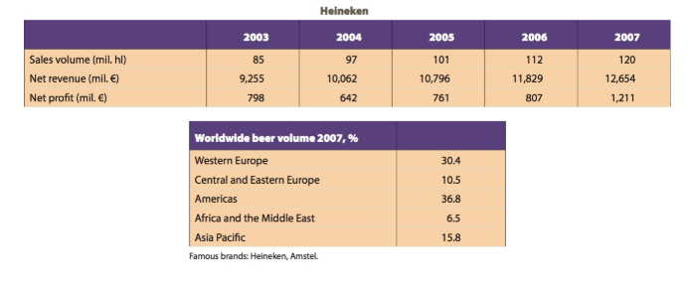
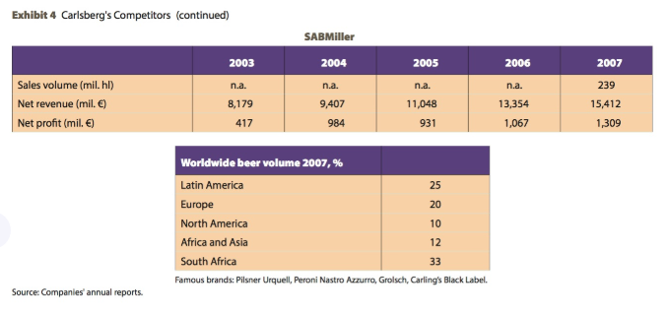

As markets around the world became increasingly consolidated, Carlsberg recognized its inability to become a truly global company. The North and South American markets had been lost to other well-known, established breweries, and the potential offered by the African markets was of limited interest. The Western European markets were already consolidated to a great extent, so Carlsberg decided to focus on Eastern Europe and Asia as a means of achieving future growth. Investments in these emerging markets were financed through revenues from activities in the Western European markets. Carlsberg’s activities in Eastern Europe, particularly in Russia, were expected to offer sizeable potential for several years. However, expectations were perhaps even greater for the long-term potential of the Asian markets, especially China, where Carlsberg was making considerable investments. In fact, Carlsberg’s emerging market focus was considered vital for the company’s ability to remain a major player in the beer industry. “We want to ensure that we have positions with future growth potential, and we will be relatively patient,” former CEO Nils Smedegaard Andersen argued in 2005. “We are unable to say anything about how long it will take, but right now we believe that a market-leading position will be interesting in five to 10 years. How interesting will depend on the competition, the economic development and many other conditions.” The increase in optimism concerning Carlsberg’s future was, therefore, due in large part to the fact that the company had abandoned its strategy of becoming a global player and instead focused on capitalizing on emerging markets.

Central to Carlsberg’s business strategy was a focus on value creation and profitable growth. The Western European strategy was to ensure “improved profitability through innovation and streamlining,” while “rapid growth and higher earnings” were emphasized in Eastern Europe. The Asian strategy was “long-term growth through building up market positions” (see Exhibit 5).

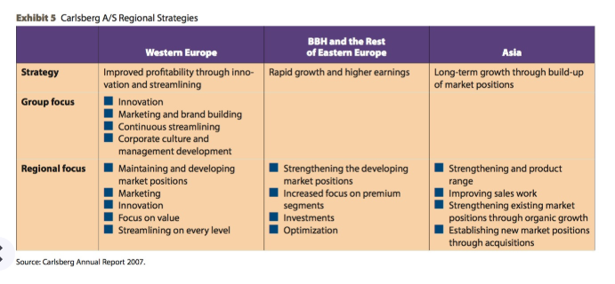

The beer industry’s mantra, according to Heineken CEO Jean-Francois van Boxmeer, was that it was not worthwhile for a brewing company to be present in a market where it was not the market leader or the runner-up. This philosophy was shared by Carlsberg, as indicated by Carlsberg’s press officer, Jens Peter Skaarup: “What is important is the position we have on the markets in which we are present.” In relation to the consolidation of the industry, he argued that “competition is something we are happy about. It makes us more ‘fit for fight.’”

Carlsberg in Russia

Once Carlsberg gained access to BBH through the Orkla ASA merger, the scene was set for Carlsberg to reap the major benefits of the emerging Eastern European markets. In 2007, when Carlsberg owned 50 percent of BBH’s shares, the Russian brewery held a market share of 37.6 percent in Russia and was the market leader. BBH operations in Eastern Europe—Russia, the Ukraine, the Baltic states, Kazakhstan, Uzbekistan and Belarus— accounted for 23 percent of Carlsberg’s revenue in 2007. The Russian market was undoubtedly the most import- ant for BBH, as it represented 79 percent of sales volumes and 86 percent of operating profit. From 2006 to 2007, the Russian market grew by 16 percent, while annual beer consumption per capita amounted to 75 liters (the average in the Scandinavian markets was 65 liters).

This positive development was expected to continue in Russia in the coming years, as vodka consumption was declining due to new taxes on liquor, which increased the price of vodka. In fact, the Russian market was considered to be one of the fastest-growing beer markets in the world.

Carlsberg’s strategy in terms of BBH and the Russian market was to grow organically by capturing new market share. The company doubted that the Russian state would accept more acquisitions by a company that was the absolute market leader. However, for Christian Ramm-Schmidt, BBH’s CEO, organic growth was not a problem: “I cannot see why that should not be possible. BBH is a national company, and it has the best brands, the best distribution and strong management. That should suffice to capture one to two percentage points a year.” In order to support this strategy, Carlsberg invested in BBH’s production capacity, infrastructure and logistics, as well as in the building of strong brands through product development and advertising.

BBH’s best-selling brand was Baltika, “a foamy, golden brew with a delicate flavour of hops and the aroma of first-class malt.” It was also Russia’s leading brand with a market share of 38 percent in 2007. In order to reduce Carlsberg’s dependency on the Russian market, the company had great expectations for Baltika on an international scale, and planned to introduce the brand in Asia and the United States. “I can see possibilities for Baltika in most parts of the world,” explained Jørgen Buhl Rasmussen. “Just like you can sell Czech beer almost everywhere today, I believe the same could happen for a brand like Baltika.” Furthermore, Buhl Rasmussen did not believe that introducing Baltika in other markets would have negative effects on Carlsberg’s other brands: “We do not see any risk at all of cannibalizing our own brands.” BBH also distributed the Carlsberg Pilsner and Tuborg brands to the Russian market, where the aim was to capture the premium segments. In fact, the Tuborg brand was BBH’s most important international brand, as it represented 11 percent of revenue in 2007. The Carlsberg Pilsner brand accounted for two percent of revenue in the same year.

However, as the Russian market was attractive, Carlsberg was not the only international brewing company interested in capturing market share as the Western European and American markets began to stagnate. Heineken acquired five breweries in Russia in 2005 and was the third-largest beer company in the Russian market in terms of volume by 2007. In addition, Heineken was selling local brands, such as Volga and Ochata. South African/British SABMiller was also active in the Russian market with a six percent market share and was planning to acquire more Russian breweries.

Carlsberg in China

Carlsberg’s history in China spanned as far back as the late 1890s when the first barrels of beer were exported from Denmark. It was, however, not until 1981—when Carlsberg Brewery Hong Kong was established—that Carlsberg began to produce beer in China. The Chinese market was considered highly important for Carlsberg, even though the yearly per capita consumption of beer was just 29 liters in 2007. Given its vast size and high population, China was the world’s largest market in terms of production and consumption, and the market’s estimated growth rate was up to eight percent per year, compared to 0.7 percent in the United States and 2.5 percent in Europe. In other words, the market was not to be underestimated.

The Chinese beer market was immensely fragmented and highly regionalized with no truly national brewery. Local and regional non-premium brands dominated and price was often the determining factor. These types of beer constituted more than 95 percent of total beer sales. In addition, entry barriers were considered to be very high, and the industry was capital intensive in terms of production and distribution. In order to be profitable, it was necessary to be either number one or number two. For that reason, competition had led to a process of consolidation, where the large international breweries mainly competed on buying shares of regional and local breweries.
Following initial setbacks, which led to a complete overhaul of the original strategy, Carlsberg was positioned somewhat differently from its competitors in the competition for the Chinese market. In 2000, Carlsberg had entered into a 50/50 joint venture with the Thai company Chang Beverages Pte Ltd—a leading player in Asian markets for alcoholic beverages—and created Carlsberg Asia Ltd. (CAL) to strengthen Carlsberg’s position in the Asian markets. In the important southeastern Chinese market, however, CAL met fierce competition, and earnings and sales did not take off as expected. In 2003, Anheuser-Busch, SABMiller, Interbrew and Heineken together held a substantial proportion of shares in China’s four largest breweries, and controlled more than 30 percent of the Chinese beer market in collaboration with their partners. Furthermore, as time passed, disagreements between Carlsberg and Chang Beverages arose, which eventually led to Carlsberg pulling out of the joint venture in 2003. However, as this move was allegedly a violation of the contract between the two partners, Carlsberg was forced to pay compensation of kr734 million. As a result of this episode, Carlsberg not only experienced severe financial losses but also lost three strategically important years in which to establish itself in the Chinese and Asian beer markets. During these years, other international competitors acquired important market share in the southeast Chinese beer market, while Carlsberg, with its assets first tied up in Thailand and later finding itself financially strained from the lawsuit, was unable to muster the financial strength needed to acquire new production facilities and enter the competition.

This significant setback inhibited Carlsberg from taking part in the initial consolidation process in south- east China, which caused the company to revise its strategy for Asia and the Chinese market. The result was a focus on the highly fragmented, poor Western Chinese provinces. “Our strategy is to pursue the provinces in the west, as we can buy cheap and because it is a foundation for growth,” explained Carlsberg’s information officer, Margrete Skov. She continued, “The good forecasts for growth are a result of China’s ‘go west’ policy with large investments in the provinces in the west. That gives a larger economy and better sale opportunities.”

The cornerstone of Carlsberg’s new strategy was a focus on achieving leadership and first-mover advantages in Western China, while avoiding the fierce com- petition in the southeast. Geographically, the Western Chinese region included five provinces, which covered one-third of China and had a population of around 100 million. The Western regions were the poorest parts of China, and the living standards and level of beer consumption were lower than the country averages. In the Western province of Yunnan, for instance, yearly beer consumption per capita only amounted to four liters, in contrast to 70-90 liters in the big eastern cities.

Nevertheless, Carlsberg expected living standards and beer consumption to rise rapidly. According to Michael Fredskov Christiansen, director of the Chinese operations, it was crucial for the company to be present in Western China when growth accelerated. He expected Carlsberg’s turnover to rise in line with the general growth in the Chinese beer market. In addition, the Western Chinese market was quite fragmented, and none of the other large players were present, as they all concentrated on the southeast.

Carlsberg’s 2007 Annual Report indicated that the company’s strategy was “to build up a leading position in these emerging markets through acquisitions and subsequent strong organic growth, so that Asia makes a greater contribution to Carlsberg’s overall earnings in the future.”

In 2007, Carlsberg had operations in 20 brewery plants and had 4,756 employees in China. Only a handful of the Chinese breweries were fully owned by Carlsberg, while the rest were operated through joint ventures with local partners, the Danish Industrialization Fund for Developing Countries (IFU), and local authorities. These efforts gave Carlsberg an overall market share of approximately 55–60 percent in Western China, making it the only international brewery with a leading position in that region. In addition to selling local brands, Carlsberg experienced increasing success with Carlsberg Chill, a brand designed for the Chinese market. This beer targeted the more exclusive segments and was distributed not only in Western China but also in the east. In this respect, Jørgen Buhl Rasmussen argued, “We are interested in approaching nearby areas by continuously moving from the west towards central China — for instance through acquisitions.” However, he also stated, “alone in Western China, the possibilities are enormous. We control approximately 60 percent of [the] Western China [beer market] in an area of a population of approximately 120 million. That is far more than Great Britain and Scandinavia together, and it is a market where the consumers continuously buy better, more expensive beer.”

Even though the Asian investments had yet to show their full potential, former CEO Niels Smedegaard Andersen emphasized, “We are in China to create a position. And we are not counting on making money in perhaps five to 10 years. Carlsberg has to establish new markets.” He also argued, “We consider Western Europe to be a mature, stagnating market. Russia and Eastern Europe are growth markets, while Asia is a developing market.”

Considering Carlsberg’s activities in emerging markets, CEO Jørgen Buhl Rasmussen was optimistic. He was convinced that the company’s timely and successful emerging market strategy and positioning had ensured that Carlsberg was prepared to successfully capitalize on its investments in the emerging economies. However, Rasmussen was fully aware that the majority of the company’s revenue was still generated in the stagnating Western European markets and that new sources of revenue were needed. At the same time, the BBH success story was likely to soon be affected by ever-fiercer com- petition, and the Russian government was contemplating worrisome taxation proposals for alcohol in general and beer in particular, which could seriously challenge the profitability of Carlsberg’s Russian operations. Moreover, despite magnificent forecasts for the Asian markets, the annual consumption per capita was still humble and had yet to take off. Therefore, Carlsberg’s shareholders would need time and patience if they wished to see whether Carlsberg’s emerging market strategy would suffice as a response to the operational, competitive and regulatory challenges that these markets posed. In the longer term, the payoff could be significant.

**THE FOLLOWING PAGE CONTAINS THE CASE STUDY TEMPLATE (ITS MORE OF A VERY DETAILED OUTLINE. ANSWER THE QUESTIONS IN THE BULLET ARRANGEMENT)

When complete just send the bulleted outline back to me.

Case Analysis

I. Introduction and Decision Problem (5%)

II. Situation Analysis (SWOT) (20%)

A. Internal Analysis (Intra-organizational)
1. Strengths
2. Weaknesses

B. External Analysis (General Environment, Industry and Competitors)
1. Opportunities
2. Threats
III. Strategic Options (3 or 4) (10%)
IV. Intra-Option Analyses (30%)

A. Option 1: Status Quo (No change in current strategy)
1. Pros (2 or more)
2. Cons (2 or more)

B. Option 2: ____________________________________________
1. Pros (2 or more)
2. Cons (2 or more)

C. Option 3: __________________________________________
1. Pros (2 or more)
2. Cons (2 or more)

D. Option 4: __________________________________________
1. Pros (2 or more)
2. Cons (2 or more)

V. Inter-Option Analysis and Recommendation (10%)
(Select four or more evaluation criteria and assign importance weight (1=low … 5=high) to each criterion.
Get weighted total for each option. Select option with highest weighted total.

VI. Implementation Plan (5%)

VII. Plan for Assessing the Recommended Action (5%)

VIII. Write-Up (Organization, Grammar, etc.) (15%)

